**Danger Alert**

**Pak Shing Kan, Ryan Kwong, Varun Reddy Mallepally**

**Team 10**

**CS157A Fall2020**

### **Table of Content**

1. Functional Requirements
2. The ERD
3. Schemas and Explanations

### **1. Functional Requirements**

This application provides functionality for our three types of users, viewers, posters, and authorities. Additionally an admin user is included as a separate type of user.

Viewers will not require an account to view posts but they will have the least access to functions of the application. Viewers are able to search through the posted reports by city.

Posters have the same privileges as viewers in terms of viewing posts. Posters are able to post a report by providing the necessary information (incident, address, etc). Posters can update or edit their post with updated information or clarification. Posters can also search and reply to other users' posts that are pertaining to the same crime.

Authorities will have access to the poster’s contact information in order to follow up on reports. They will also be able to flag certain reports to notify them if any similar reports are posted.

Admins have the ability to edit or remove any user’s posts. This is to allow false reports to be filtered out.

**Functions**

**Reporting/Posting Information**

* The user will be able to post a report of an incident
* The system will require the user to fill out a form about said incident. This information will be stored in the database

**View Posted Reports**

* The user will be able to see a post and view the corresponding report
* The system will provide the report the user wishes to view

**Update/edit post**

* The user will be able to update/edit their post. The admin is able to update/edit any post
* The system will limit access based on account type

**Reply to posts**

* The user will be able to reply to other users’ posts.
* The system will link the replies to the corresponding report within the database

**Notifications**

* Users can request that they are notified of new incidents in an area
* System will check for new incidents and return those fitting indicated criteria

**Create User Account**

* User accounts are only required for doing more than just viewing. Different account types include posters, authorities, and admins.
* The system provides a form to create an account

**Flag/remove false reports**

* Admins can flag or remove reports deemed incorrect or not relevant
* System will remove designated reports from database and add/remove flags as requested

**Search for Reports**

* Users are able to search through the database for posts with given parameters.
* The system will return to the user any reports matching their request parameters and let them know if none are found.

**User Feed**

* The user will see a list of recent posts from other users.
* The system will retrieve the recent posts and display them on the user’s activity page

**Save Posts**

* User will be able to save any posts to view later
* System will flag the posts saved by the user and display them in the “Saved Posts” Tab

**Get User Information**

* Authorities are able to retrieve the contact information of the poster in order to follow up investigation
* System will ensure that only authorities are able to see this information when displaying reports/posts

### **2. The ERD**

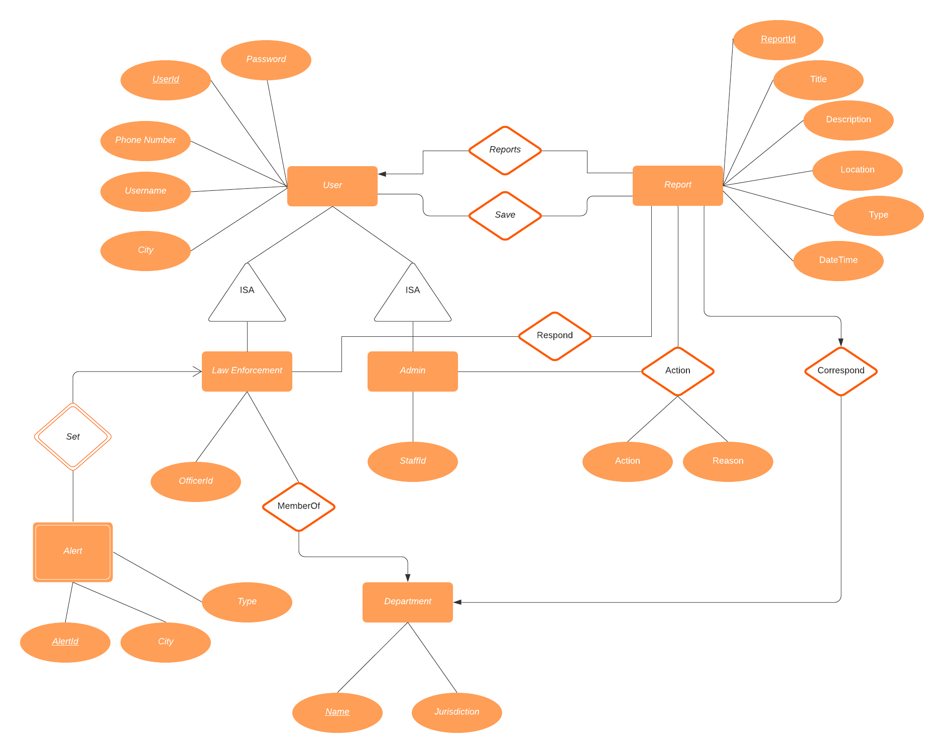

### **3. Schemas and Explanations**

1. Users(userId, username, password, phone number, city)

* Contains all the user information, and sets userId as P.K.
* City will be used for filtering relevant reports on the homepage.

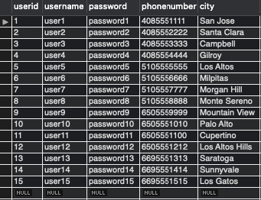

1. Report(ReportId, Title, Description, Location, Date/Time, Type)

* Contains information of a report which will be inputted by form by user/visitor.

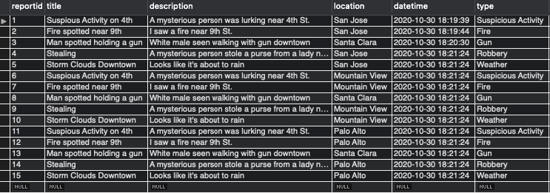

1. Admin(userId, staffid)

* Contains admin user information. Use userId and staffId as keys.

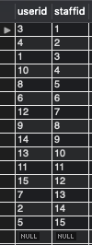

1. Law Enforcement(userid, officerid)

* Contains information of each officer and his/her department.
* Their actual offierId and their department name will be combined as a key.

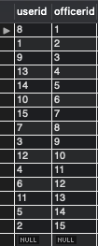

1. Alert(officerid, alertid, type, city)

* An alert will be set by an authority(law enforcement) which contains the alert type and which city it happened.

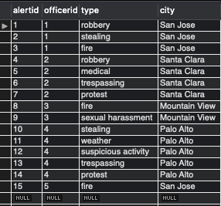

1. Respond(officerid, Reportid)

* A table to store the record for which officer takes care of which report.
* Mainly used as a log for logging which officer initiated an investigation .

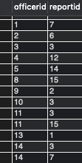

1. Department(Name, Jurisdiction)

* Contains different department information such as their name (Police, Highway Patrol, Fire Department and so on) and their jurisdiction area.

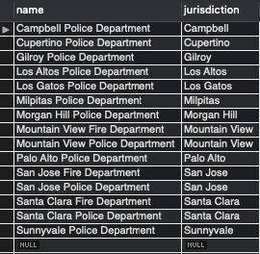

1. Save(userId, ReportID)

* A table for each user to store reports for future referencing.

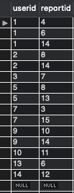

1. Action(staffID,ReportID, Reason, action)

* A table for logging what actions does the admin take to the report and why.
* For example, the admin can remove the report if it is misleading/misinformation.

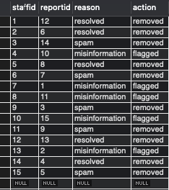

1. Reports(userid, reportid)

* A logging table for storing which report is filed by which user.
* It will be used for authorities to ask further questions.

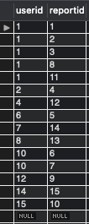

1. MemberOf(officerid, departmentName)

* Keeps track of where each law enforcement is from

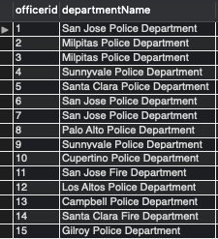

1. Correspond(reportid, departmentName)

* Keeps track of which reports correspond to a specific department

